 **Practice Sheet-3**

**Operating System (Linux)**

**CST108**

**Q.1** Consider a system with a set of process P1, P2 and P3 and their CPU burst times, priorities and arrival time being mentioned as below:

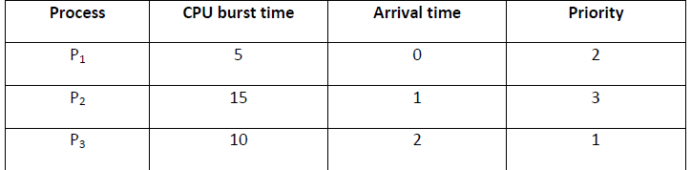

Assume 1 to be the highest priority and calculate the following:

1. Average waiting time using FCFS, SJF (preemptive and non-preemptive) and priority (preemptive and non-preemptive) scheduling mechanisms.

2. Average turnaround time using FCFS, SJF (preemptive and non-preemptive) and priority (preemptive and non-preemptive) scheduling mechanisms.

3. Assume time quantum to be 2 units of time. Calculate average waiting time and average turnaround time using Round Robin Scheduling.

**Q.2** Consider a system with a set of process P1, P2 and P3 and their CPU burst times:

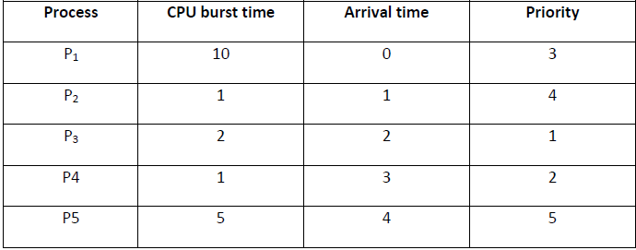

Draw the Gantt charts and calculate average turnaround time & average waiting time for each of the following algorithms:

1. RR (quantum=2)

2. Priority

**Q.3** Consider a system with a set of process P1, P2 and P3 and their CPU burst times:

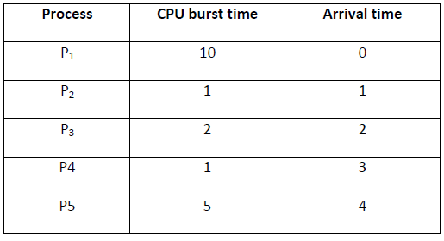

Draw the Gantt charts and Calculate Average Turnaround time & average waiting time for each of the following algorithms:

1. FCFS

2. SJF

3. SRTF

**Q.4** Assume you have the following jobs to execute with one processor, with the jobs arriving in the order listed here:

|  |  |  |
| --- | --- | --- |
| **Process** | **Burst** | **Arrival** |
| P1 | 80 | 0 |
| P2 | 20 | 10 |
| P3 | 10 | 10 |
| P4 | 20 | 80 |
| P5 | 50 | 85 |

1. Suppose a system uses RR scheduling with a quantum of 15. Create a Gantt chart illustrating the execution of these processes.
2. What is the turnaround time for process p3?
3. What is the average wait time for the processes?

**Q.5** Assume you have the following jobs to execute with one processor, with the jobs arriving in the order listed here:

|  |  |
| --- | --- |
| **Process** | **Burst** |
| P1 | 80 |
| P2 | 20 |
| P3 | 10 |
| P4 | 20 |
| P5 | 50 |

a. Suppose a system uses FCFS scheduling. Create a Gantt chart illustrating the execution of these processes?

b. What is the turnaround time for process p3?

c. What is the average wait time for the processes?

**Q.6** Consider the following table, draw gantt charts for the given algorithms:

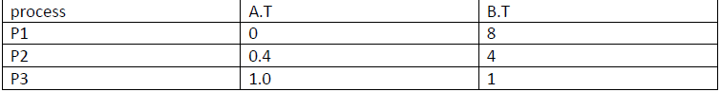

1. FCFS

2. SJF

3. SRTF

Calculate the average turnaround time.